Lab Session – Day 7

**Question:**

Use classicmodels. Show the total sales done by each customer using below tables and sort it by highest to lowest sales.

Sales = SUM(priceEach * quantityOrdered)

* Customers
* Orders
* Orderdetails

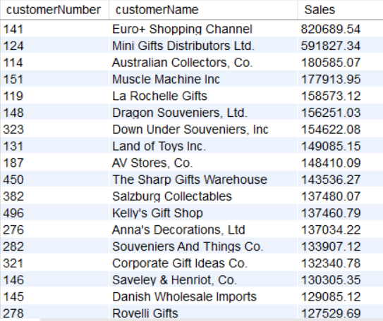The output should look as shown in below image.

**Solution:**

Write the below query in MySQL workbench.

